FDI: 2 groups: Jiangsu + Guangdong are way above the rest of the group.

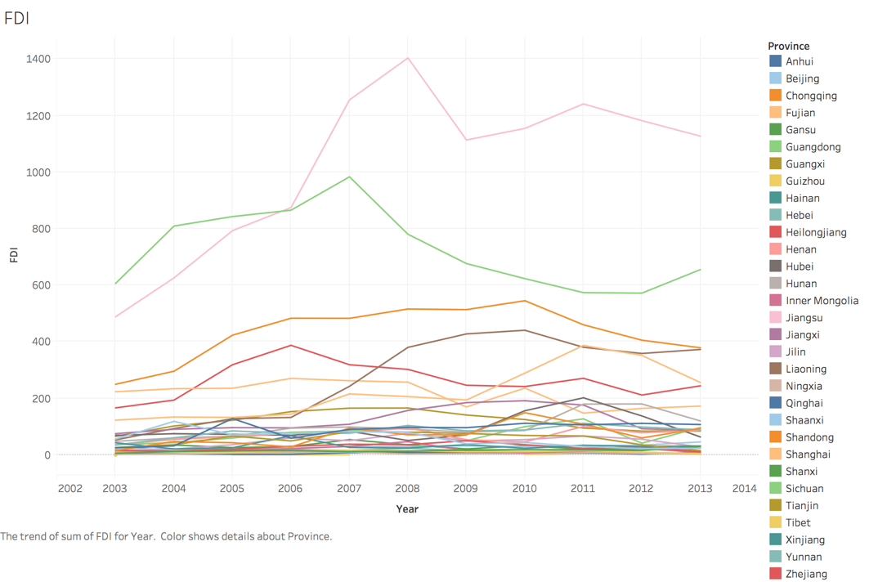

Area/KM2:

3 groups:

Xingjiang + Tibet + Inner Mongolia

Qinghan + Sichuan + Gangsu + Yunnan + Heilongjiang

Rest

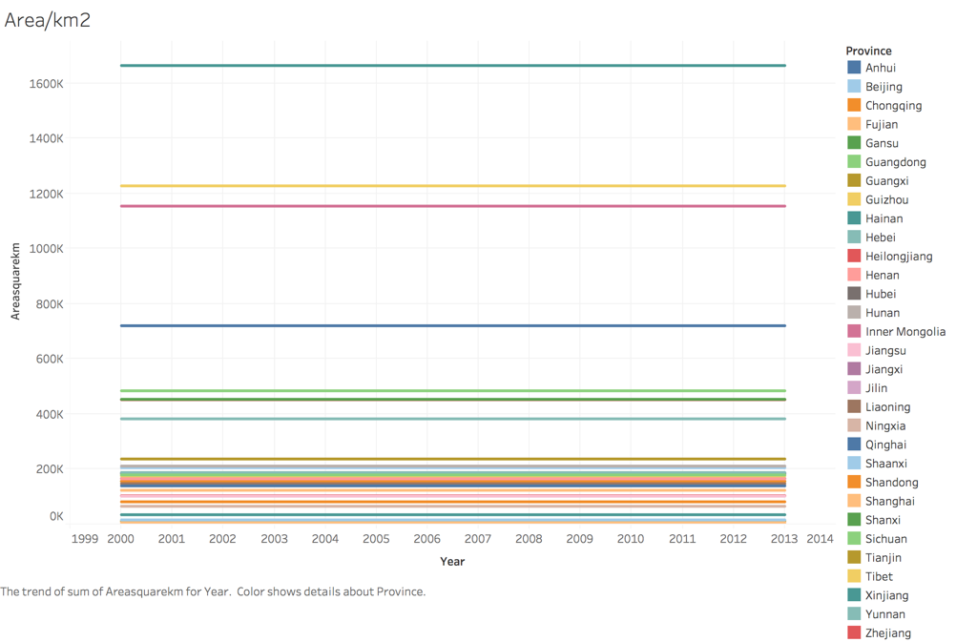

Pop: not much we can do to group

AboveSizeInd:

3 groups:

Zhejiang + Guangdong + Shangdong

Henan + Liaoning + Fujian + Anhui + Hubei + Hebei + Sichuan + Shanghai

Rest

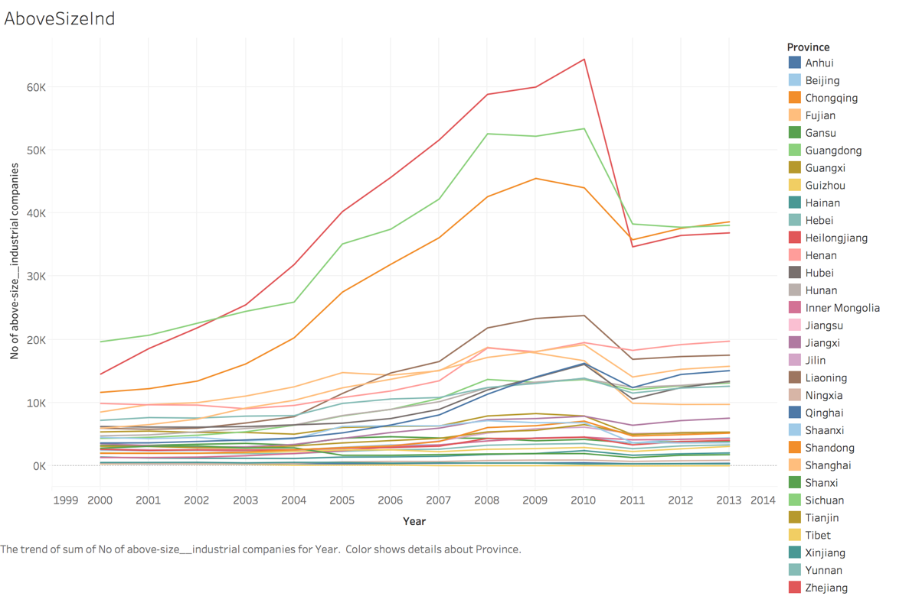

GDP:

3 groups:

1. Tianjing + Beijing + Shanghai
2. Jiangsu + Inner Mongolia + Zhejiang + Laoning + Guangdong + Fujian + Shandong
3. Rest

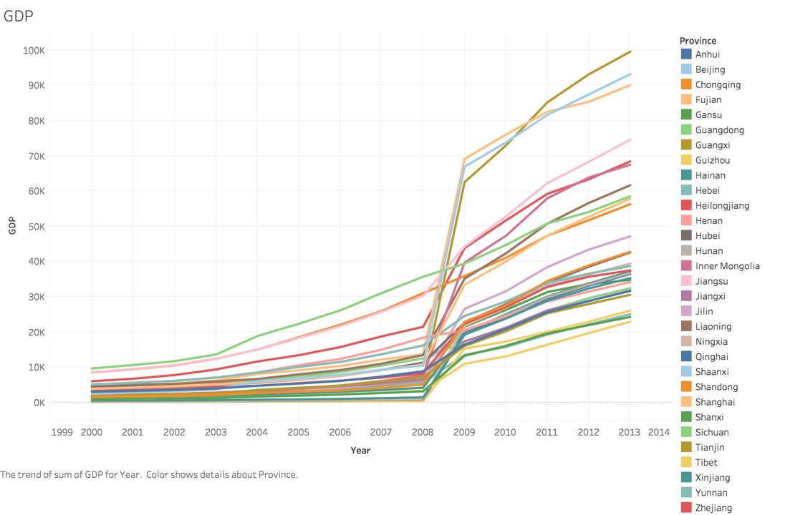

GDPpercap:

3 groups:

1. Tianjing + Beijing + Shanghai
2. Jiangsu + Inner Mongolia + Zhejiang + Laoning + Guangdong + Fujian + Shandong
3. Rest

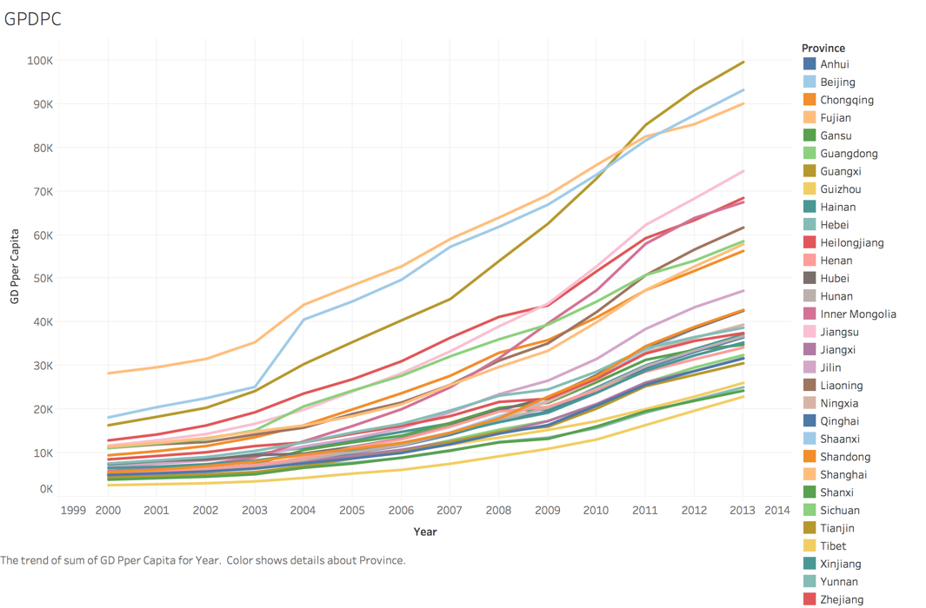

PubEmployment:

2 groups:

1. Sichuan + Shangdong + Henan + Guangdong + Hebei + Hunan

2. Rest

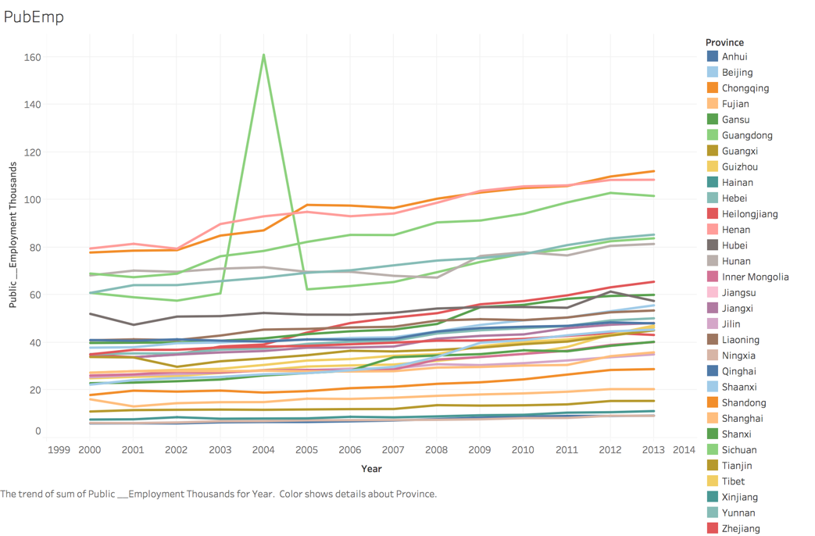

PubExpenditure: not too interesting to group: 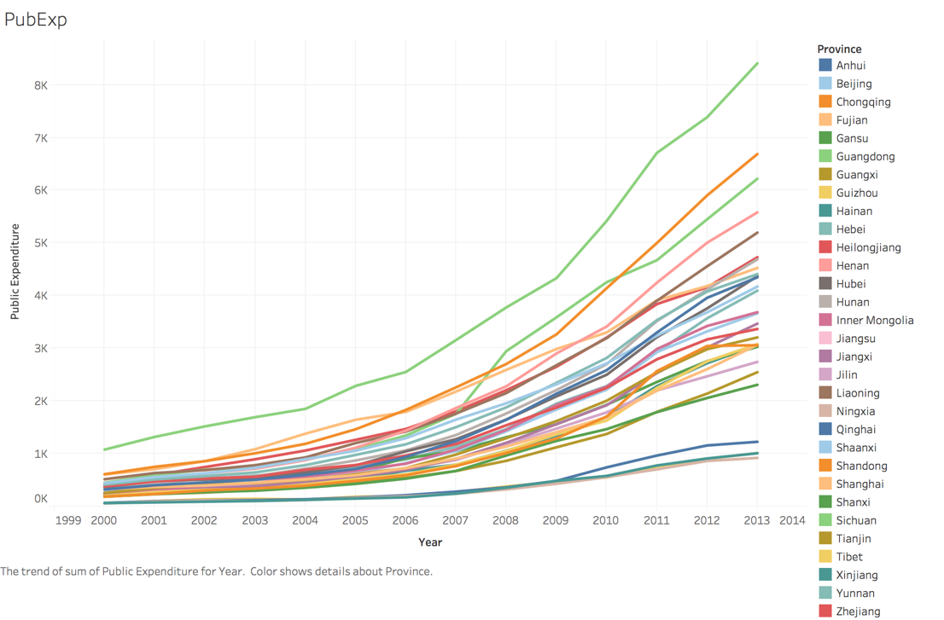

UrbanPopRatio:

2 groups:

1. Shanghai + Beijing + Tianjin
2. Rest

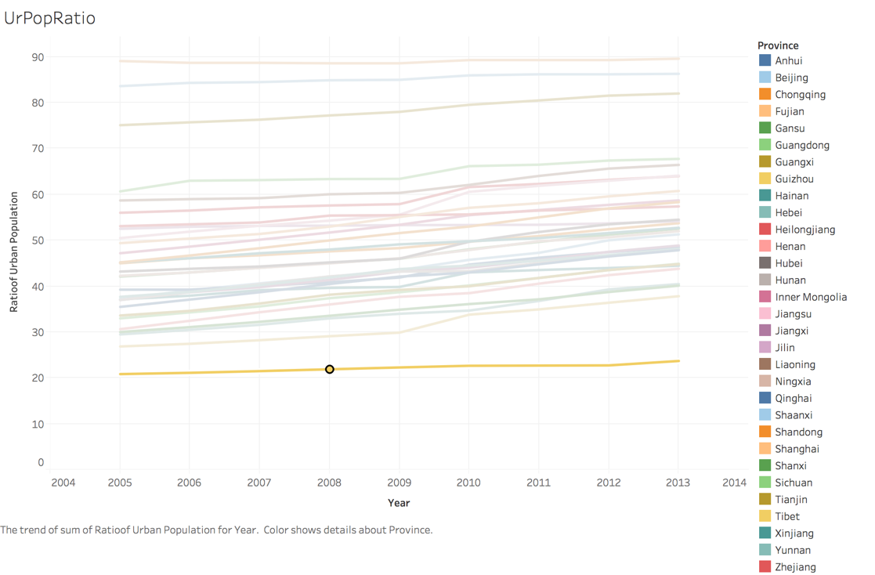

Urban Area:

2 groups:

1. Guangdong + Shandong + Liaoning(?)
2. Rest

